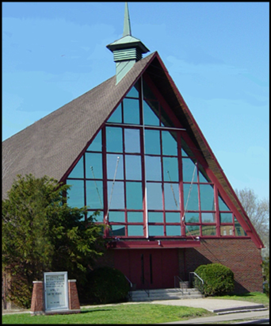
Grace Presbyterian Church
Facilities Rental Application/Contract
Please Print

Name of Applicant _____________________________________________________________
(Individual or Organization)

Use Required (Wedding, Funeral, Meeting, etc.) _______________________________________

Date (Separate applications are required for each date) _________________________________

Time Needed for Event (To nearest ½ hour) ____________ Expected Attendance __________

Name of Person Financially Responsible for Event ___________________________________

Address _______________________________________ Phone _____________________

_______________________________________ Cell _______________________

_______________________________________ eMail _____________________

Signature ______________________________________ Date ______________________

Your signature constitutes tacit agreement with all church rules and regulations governing conduct while using church property as well as the laws of the City of Lakewood, the State of Ohio and the United States. Grace Presbyterian Church does not assume liability or responsibility for injury to persons making use of church facilities nor for lost, stolen or damaged property belonging to groups or individuals which have been brought onto church premises. This rental application/contract must be filled out fully and emailed, faxed or posted by US Mail or electronically to the church office. Fees for the use of Grace Church’s facilities will be computed by the church office based on this form and will be communicated to the applicant after the application has been approved by the church’s governing body.

Rooms/Furnishings/Equipment Needed for Event (Check All That Apply):

Social Hall Sanctuary Kitchen Chapel

Parlor Chair(s) Table(s) Lecturn Sound System

Handicapped Accessibility (Elevator)

MAKE CHECKS PAYABLE TO:

Grace Presbyterian Church
1659 Rosewood Avenue
Lakewood, Ohio 44107
(216) 228-6060
FAX: (216) 228-9391

